
Strictly Confidential
No External Distribution

Global Yield Curve Building

Version | Date | Author
1.0 | 30 April 2018 | Joseph Ye

This technical document gives an insight into the working mechanism of the global yield curve engine, how it calibrates multiple yield curves simultaneously in a synchronous fashion, and how it improves the quality of swap delta risks.

Background
The creation of the curve engine and its synchronously calibrated yield curves were requested to address multiple pricing and risk calculation deficiencies exhibited by the exiting yield curve calibration analytics at MHI. One of the main causes of such deficiencies is the old logic’s inability to capture the inter-dependencies among all the yield curves. In a real world market all the OIS curves, tenor Libor curves, tenor basis curves and cross currency basis curves can heavily depend on one another and may exhibit the same movements on their curve shape when responding to the same market shock. Since the existing curve building analytics at MHI only allow yield curves to be built one after another, there is a disjointed relationship among these curves and existing analytics does not capture the co-moving nature of market yield curves.
Such problem is typified when we build the Eonia curve using 3MLibor-OIS basis instruments. The chart below shows an Eonia and EUR 3M curve on 21 September 2017. The double arrows represent basis instruments between these two curves.

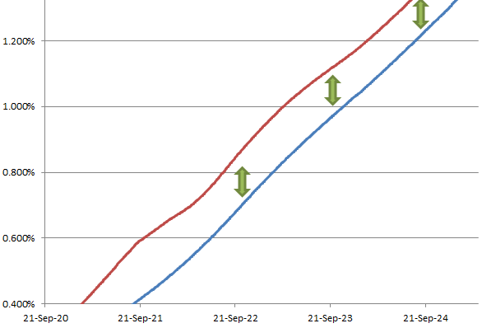
Figure 1. Eonia curve is built off the EUR 3M curves using Libor-OIS basis
Theoretically, the use of Libor-OIS basis instruments should’ve enforced a good level of co-movement between the Eonia curve and EUR 3M Libor curve when the basis amounts are not changing.
However, since the existing curve building analytics treat these two curves individually, when we simulate a movement on the EUR 3M curve by perturbing one of its calibration instruments, no impact is reflected on the OIS curve and the shape of the OIS curve won’t adapt to the shock on the 3M curve. Such problem will not only lead to mispricing of swap instruments, it also makes the delta risk analytics in MLib fail to capture the important cross-curve risks.

Global Yield Curve Engine
To address all those problems that arise from the asynchronous nature of existing MLib curves, the solution is to find a way to calibrate all yield curves synchronously in one go. As a result we’ve created a global yield curve engine to achieve this goal.
We already know that a EUR 3M curve is dependent on the Eonia curve as discounting curve and the Eonia curve is in return also dependent on the EM curve because it’s built using 3MLibor-OIS basis with 3M swap par rates. When both curves are unknown the only way to calibrate them together is to put them into a solver and solve for discount factors on both curves at the same time. As a result the core of the yield curve engine is a gigantic cross-curve Newton Raphson solver.
It’s easy to see that the cross-curve solver is an extension of what we already do at the single curve’s level. For instance, the revamped OIS curve also uses a Newton Raphson solver to collectively calibrate the key tenor points on the curve using all of its calibration instruments. The solving formula and curve level Jacobian matrix looks like this:
$r_{i+1}=r_{i}-J_{PV}^{-1}\left(r\right)PV(x)$ (1)

$$J_{f}\left(x\right)=\left[\begin{aligned}\frac{∂{PV}_{OIS_{1}}}{∂r_{OIS_{1}}} ⋯ \frac{∂{PV}_{OIS_{1}}}{∂r_{OIS_{i}}} ⋯ \frac{∂{PV}_{OIS_{1}}}{∂r_{OIS_{n}}} \\ ⋮ ⋱ ⋮ ⋱ ⋮ \\ \frac{∂{PV}_{OIS_{i}}}{∂r_{OIS_{1}}} ⋯ \frac{∂{PV}_{OIS_{i}}}{∂r_{OIS_{i}}} ⋯ \frac{∂{PV}_{OIS_{i}}}{∂r_{OIS_{n}}} \\ \\ ⋮ ⋱ ⋮ ⋱ ⋮ \\ \frac{∂{PV}_{OIS_{n}}}{∂r_{OIS_{1}}} ⋯ \frac{∂{PV}_{OIS_{n}}}{∂r_{OIS_{i}}} ⋯ \frac{∂{PV}_{OIS_{n}}}{∂r_{OIS_{n}}} \\ \end{aligned}\right]$$

Where $r_{i}$ represents the logarithm of discount factor on each of the target curve’s note points. We can call $r_{i}$ the curve’s state variable and hence it’s also the output of the solving routine.
The yield curve engine goes one step further and considers the sensitivity of each instrument’s PV on every single curve against the log discount factor on each note point represented by each instrument on every curve. This means cross curve sensitivities are also considered. Also, the state variable on each component curve must be made strictly consistent with each other, i.e. all of them ought to be logarithm of the target curve’s discount factors.
In the case of dual-bootstrapping where only the OIS curve and a swap curve are calibrated simultaneously, the Jacobian matrix looks as follows:
$$J_{f}\left(x\right)=\left[\begin{aligned}\begin{aligned}\frac{∂{PV}_{OIS_{1}}}{∂r_{OIS_{1}}} ⋯ \frac{∂{PV}_{OIS_{1}}}{∂r_{OIS_{i}}} ⋯ \frac{∂{PV}_{OIS_{1}}}{∂r_{OIS_{n}}} \\ ⋮ ⋱ ⋮ ⋱ ⋮ \\ \frac{∂{PV}_{OIS_{i}}}{∂r_{OIS_{1}}} ⋯ \frac{∂{PV}_{OIS_{i}}}{∂r_{OIS_{i}}} ⋯ \frac{∂{PV}_{OIS_{i}}}{∂r_{OIS_{n}}} \\ \\ ⋮ ⋱ ⋮ ⋱ ⋮ \\ \frac{∂{PV}_{OIS_{n}}}{∂r_{OIS_{1}}} ⋯ \frac{∂{PV}_{OIS_{n}}}{∂r_{OIS_{i}}} ⋯ \frac{∂{PV}_{OIS_{n}}}{∂r_{OIS_{n}}} \\ \end{aligned}\begin{aligned}\frac{∂{PV}_{OIS_{1}}}{∂r_{{STD}_{1}}} ⋯ \frac{∂{PV}_{OIS_{1}}}{∂r_{{STD}_{i}}} ⋯ \frac{∂{PV}_{OIS_{1}}}{∂r_{{STD}_{n}}} \\ ⋮ ⋱ ⋮ ⋱ ⋮ \\ \frac{∂{PV}_{OIS_{i}}}{∂r_{{STD}_{1}}} ⋯ \frac{∂{PV}_{OIS_{i}}}{∂r_{{STD}_{i}}} ⋯ \frac{∂{PV}_{OIS_{i}}}{∂r_{{STD}_{n}}} \\ \\ ⋮ ⋱ ⋮ ⋱ ⋮ \\ \frac{∂{PV}_{OIS_{n}}}{∂r_{{STD}_{1}}} ⋯ \frac{∂{PV}_{OIS_{n}}}{∂r_{{STD}_{i}}} ⋯ \frac{∂{PV}_{OIS_{n}}}{∂r_{{STD}_{n}}} \\ \end{aligned} \\ \begin{aligned}\frac{∂{PV}_{{STD}_{1}}}{∂r_{OIS_{1}}} ⋯ \frac{∂{PV}_{{STD}_{1}}}{∂r_{OIS_{i}}} ⋯ \frac{∂{PV}_{{STD}_{1}}}{∂r_{OIS_{n}}} \\ ⋮ ⋱ ⋮ ⋱ ⋮ \\ \frac{∂{PV}_{{STD}_{i}}}{∂r_{OIS_{1}}} ⋯ \frac{∂{PV}_{{STD}_{i}}}{∂r_{OIS_{i}}} ⋯ \frac{∂{PV}_{{STD}_{i}}}{∂r_{OIS_{n}}} \\ \\ ⋮ ⋱ ⋮ ⋱ ⋮ \\ \frac{∂{PV}_{{STD}_{n}}}{∂r_{OIS_{1}}} ⋯ \frac{∂{PV}_{{STD}_{n}}}{∂r_{OIS_{i}}} ⋯ \frac{∂{PV}_{{STD}_{n}}}{∂r_{OIS_{n}}} \\ \end{aligned}\begin{aligned}\frac{∂{PV}_{{STD}_{1}}}{∂r_{{STD}_{1}}} ⋯ \frac{∂{PV}_{{STD}_{1}}}{∂r_{{STD}_{i}}} ⋯ \frac{∂{PV}_{{STD}_{1}}}{∂r_{{STD}_{n}}} \\ ⋮ ⋱ ⋮ ⋱ ⋮ \\ \frac{∂{PV}_{{STD}_{i}}}{∂r_{{STD}_{1}}} ⋯ \frac{∂{PV}_{{STD}_{i}}}{∂r_{{STD}_{i}}} ⋯ \frac{∂{PV}_{{STD}_{i}}}{∂r_{{STD}_{n}}} \\ \\ ⋮ ⋱ ⋮ ⋱ ⋮ \\ \frac{∂{PV}_{{STD}_{n}}}{∂r_{{STD}_{1}}} ⋯ \frac{∂{PV}_{{STD}_{n}}}{∂r_{{STD}_{i}}} ⋯ \frac{∂{PV}_{{STD}_{n}}}{∂r_{{STD}_{n}}} \\ \end{aligned}\end{aligned}\right]$$

On this cross-curve Jacobian matrix, the sub matrixes in blue represent calibration instrument’s PV sensitivities against their own curve’s instruments, whereas the sub matrixes in green represent cross-curve sensitivities.
It is important for one to appreciate that despite being an extension of the curve level Jacobian matrix, the engine Jacobian is a lot more complex for a couple of reasons. Firstly, there are cross curve sensitivities. MLib needs to carefully and correctly organise the inter-dependency between cross curve instruments in order to establish true cross curve sensitivities. This will be explored in depths in the next section. Secondly, when more curves are involved in the calibration process within the engine, the Jacobian matrix must be carefully arranged for so that all parts of the matrix tally up with each other.
With the help of being able to form a cross curve Jacobian matrix, MLib is able to allow calibration instruments of all the curves to be used all at the same time. Most importantly, because it is possible to establish the sensitivity of any single instrument against the rest of all other instruments in the whole population, a movement at any single instrument’s market price will get picked up by all instruments from all the curves, effectively allowing the curves to perform co-movements and cross curve sensitivities to be captured if there is any.
Figure.2 shows how the Eonia curve moves together with the EUR 3M curve when the 5Y 3M swap par rate has been bumped by 1 basis point. Such a co-movement is legitimate because the Libor-OIS basis has not changed in this process.

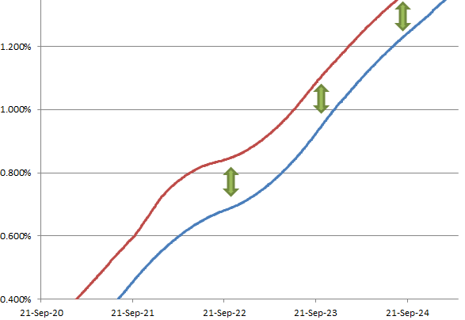
Figure.2 Co-movements of EUR 3M curve and Eonia curve

Yield Curve Inter-Dependency
In this section we will explore the inter-dependency between the yield curves, or more precisely, the inter-dependency between calibration instruments from different yield curves. Before we get to that however, we will firstly take a look at how certain calibration instruments are treated in a single curve setting.

Vanilla IRS in a 3M curve

Current Design
Take a look at the standard PV formula of a vanilla IRS in the existing single-curve setting:
$${PV}_{IRS}= R\sum_{i=1}^{M}{ τ_{i}^{a}}{ DF}_{i}^{d}-\sum_{i=1}^{N}{f_{i}^{L}{ τ}_{i}^{a}} {DF}_{i}^{d} (2)$$
We already know that in order to calibrate a 3M Libor curve using vanilla IRS the goal is to solve for Libor rates so that this PV formula equals to 0 for all IRS calibration instruments of the curve. In reality, since the calibration process solves for the 3M curve’s discount factors instead of its forward rates, the PV formula can be expanded to:
${PV}_{IRS}= R\sum_{i=1}^{M}{{ τ}_{i}^{a}}{ DF}_{i}^{d}-\sum_{i=1}^{N}{ (\frac{\frac{{DF}_{i}^{f}}{{DF}_{i+1}^{f}}-1}{τ_{i}^{f}})}{ τ}_{i}^{a} {DF}_{i}^{d}$ (3)
Where:
$R$: Market swap par rate and it’s an input;
$τ_{i}^{a}:$ Accrual date count fraction;
$τ_{i}^{f}$: Fixing date count fraction;
${DF}_{i}^{d}$: Discount factor provided by the discounting OIS curve;
${DF}_{i}^{f}$: Discount factor of the 3M curve;
Conveniently all the first four parameters are known, including ${DF}_{i}^{d}$. The only two knowns in the formula, ${DF}_{i}^{f}$ and ${DF}_{i+1}^{f}$, are related to each other via the 3M curve’s interpolation method. That means one of them can be represented as a function of the other with the help of the curve’s interpolation function. As a result we can effectively state there is only one unknown to be solved for in this PV formula.

Problems
As explained earlier it’s wrong to assume that curves can be built separately and independently as that contradicts with how yield curves behave in the real market. Therefore, it’s wrong to assume the OIS curve is independent of the Libor curves and hence wrong to assume ${DF}_{i}^{d}$ can be known prior to knowing ${DF}_{i}^{f}$;

Libor-OIS Basis Swap in an OIS curve

Current Design
Next let’s take a look at a Libor-OIS basis swap used in an Eonia curve. The PV formula of this product is typically like this:
$${PV}_{LOBasis}= \sum_{i=1}^{M}{\left({ f}_{i}^{d}-s\right)}{DF}_{i}^{d}-\sum_{i=1}^{N}{{ f}_{i}^{L} τ_{i}^{a}} {DF}_{i}^{d}$$
$$= \sum_{i=1}^{M}{(\frac{\frac{{DF}_{i}^{d}}{{DF}_{i+1}^{d}}-1}{τ_{i}^{d}}-s)}{DF}_{i}^{d}-\sum_{i=1}^{N}{{ f}_{i}^{L} τ_{i}^{a}} {DF}_{i}^{d} (4)$$
Where:
$τ_{i}^{a}:$ Accrual date count fraction;
$τ_{i}^{d}$: Fixing date count fraction of the OIS curve;
${DF}_{i}^{d}$: Discount factor of the OIS curve;
${DF}_{i}^{f}$: Discount factor of the 3M curve;
$f_{i}^{L}$: 3M Libor rates;
$s$: 3M Libor-OIS basis;

When instruments are priced at par, formula (4) can be further adapted to include the fixed leg of a 3M vanilla swap. Such an adaption has essentially replaced the unknown 3M Libor rates with a known 3M swap market par rate as seen in formula (2):
$$PV = \sum_{i=1}^{M}{(\frac{\frac{{DF}_{i}^{d}}{{DF}_{i+1}^{d}}-1}{τ_{i}^{d}}-s)}{DF}_{i}^{d}-R\sum_{i=1}^{M}{ τ_{i}^{a}}{ DF}_{i}^{d} (5)$$

Under the existing single curve building framework, in order to calibrate the OIS curve using a Libor-OIS basis instrument, both the Libor-OIS basis $s$ and IRS market par rate $R$ are given as inputs. As a result there is again only one unknown present in this formula which is ${DF}^{d}$ which can be easily determined with the help of a curve level Newton Raphson solver.

Problems
The transformation from formula (4) to formula (5) is not always warranted and guaranteed. When we use IRS par rate $R$ to help calibrate a Libor-OIS basis swap, it only makes sense if the same IRS with par rate $R$ is indeed used to calibrate the corresponding 3M Libor curve. This is however not always the case.
For example, we could build the USD 3M Libor curve using 18 futures followed by swap rates starting from 6Y onwards. All the swap instrument inputs are like this:
Swaps
6Y | 1.8565%
7Y | 1.9275%
8Y | 1.9866%
9Y | 2.0416%
10Y | 2.0909%
12Y | 2.1715%
15Y | 2.2539%
20Y | 2.3294%
25Y | 2.3577%
30Y | 0.023693

At the mean time we could be building the USD OIS curve using 3MLibor-OIS basis instruments from 1Y onwards. Because in this case the OIS curve has to rely on 3M swap par rates to go with its basis instruments, it’s inputs look like this:
Libor Swaps |  |  | Libor-OIS Basis Swaps
1Y | 1.35870% |  | 1Y | 0.12500%
2Y | 1.49710% |  | 2Y | 0.15250%
3Y | 1.60880% |  | 3Y | 0.17875%
4Y | 1.70150% |  | 4Y | 0.19875%
5Y | 1.78150% |  | 5Y | 0.21625%
6Y | 1.85650% |  | 6Y | 0.22750%
7Y | 1.92750% |  | 7Y | 0.23875%
10Y | 2.09090% |  | 10Y | 0.26250%
12Y | 2.17150% |  | 12Y | 0.27500%
15Y | 2.25390% |  | 15Y | 0.28750%
20Y | 2.32940% |  | 20Y | 0.30250%
25Y | 2.35770% |  | 25Y | 0.31000%
30Y | 2.36930% |  | 30Y | 0.31625%

Note that 3M swap par rates from 1Y to 5Y do not exist on the 3M Libor curve. When MLib uses these instruments together with the 3MLibor-OIS basis to calibrate the OIS curve, the resulted curves will not be able to price a vanilla IRS of these tenors back to input par rates.

3M Vanilla IRS + 3MLibor-OIS Basis Swap
It is quite clear that there is an inter-dependency between a 3M vanilla IRS on the 3M Libor curve and a 3MLibor-OIS basis swap of the same maturity tenor on the OIS curve. Putting the PV formula of both products together we can see there are two unknowns in two formulae, ${DF}_{i}^{d}$ and ${DF}_{i}^{f}$:
$$\left\{\begin{aligned}{PV}_{IRS}= R\sum_{i=1}^{M}{{ τ}_{i}^{a}}{ DF}_{i}^{d}-\sum_{i=1}^{N}{ (\frac{\frac{{DF}_{i}^{f}}{{DF}_{i+1}^{f}}-1}{τ_{i}^{f}})}{ τ}_{i}^{a} {DF}_{i}^{d} = 0 \\ \\ {PV}_{LOBasis}= \sum_{i=1}^{M}{(\frac{\frac{{DF}_{i}^{d}}{{DF}_{i+1}^{d}}-1}{τ_{i}^{d}}-s)}{DF}_{i}^{d}-\sum_{i=1}^{N}{ (\frac{\frac{{DF}_{i}^{f}}{{DF}_{i+1}^{f}}-1}{τ_{i}^{f}}) τ_{i}^{a}} {DF}_{i}^{d} =0 \end{aligned}\right.$$

Once this inter-dependency has been established for the global yield curve engine, cross curve solving can be easily carried out to determine the discount factors of both curves simultaneously, as if instruments from both curves came from one single curve.

Benefits of Building Synchronous Curves
The global yield curve engine and the synchronously generated yield curves have resolved a number of immediate pricing and delta risk calculation problems at MHI. Because these yield curves are internally arbitrage-free, the trading desks no long suffer from swap mispricing problems especially in more choppy markets. In addition, because we are now capturing the synchronous nature of how yield curves move in the market, we are capturing the cross curve risks when computing swap delta risks.
In the medium to long term there are more benefits to be gained from these new curves. Globally synchronous yield curves:
- Naturally fit in with high-speed large-scale yield curve publishing for a global eTrading business;

- Naturally fit in with multi-currency collateralisation of swap trading;

- Naturally fit in with multi-curve analytical risk calculations;
These future benefits are all achievable and compatible with the yield curve engine. That being said, at the time of writing this document, the yield curve engine only supports the OIS and Swap curves. More work will need to be done to support other curve types in the engine, notably tenor basis curve and cross currency basis curve. Also, certain special curve building instances such as the building of AUD curves will also need to be examined as that would involve tenor basis instruments.

Appendix 1: Code Structure
The following chart is a high level diagram on the structure of the new codes that implement the global yield curve calibration analytics. For more information please refer to the source code.

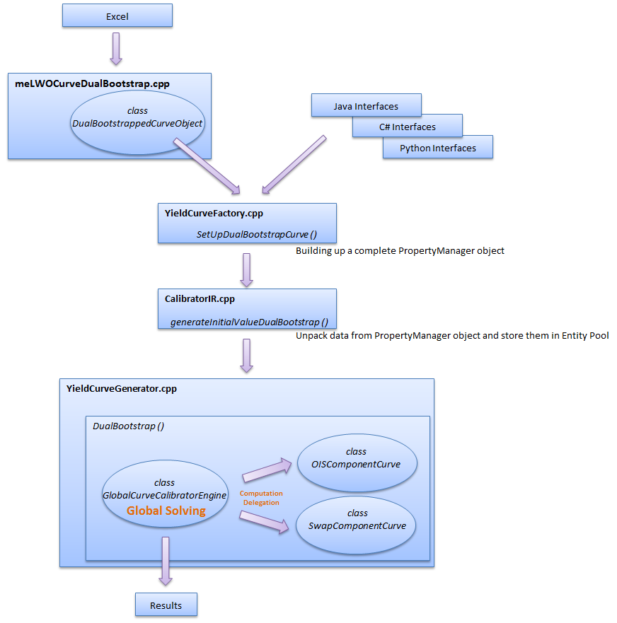

Appendix 2: Yield Curve Controls
In this appendix a number of control parameters are explained which concern the calibration of yield curves in an engine. For information on more control parameters that concern the existing single curve building analytics please refer to document ‘MLib Yield Curves in a Nutshell’.

LinearSplineJoinDate A Date
An optional field used to specify and override the join date used when using Linear-Spline interpolation. This allows the end user to fully specify which part of the curve should be Linear interpolated and which part should use Spline interpolation. Forward rates are linear before the join date and spline afterwards.

FastRebuild TRUE, FALSE
An optional field which determines if the Newton Raphson solver will re-use the Jacobian matrix and the results of the last curve build so as to speed up calibrating a yield curve or yield curve engine. Default to TRUE.

AlwaysCalcJoinDate TRUE, FALSE
The Swap curve has a dynamic futures / swap join date when using a hybrid interpolation method such as Linear-Spline interpolation. During calibration a join date is selected to provide the smoothest curve shape over the join as possible. This works well when using curves for pricing, however numerical risk calculations are more stable if we use a fixed join date. This flag allows the end user to control the join date calculation, when TRUE a join date is always dynamically calculated and we optimize for the smoothest curve shape. When set to FALSE we re-use the join date for stable numerical risk calculations. The default value is TRUE.

